PPARα Regulation of IκBα and Cross-Talk with the Glucocorticoid Receptor (GR)
PPARα Regulation of IκBα:
PPARα enhances expression of the NF-κB inhibitor IκBα, but not through a classical PPAR Response Element (PPRE). Instead, in a ligand-dependent manner, PPARα potentiates the ability of the NF-κB subunit p65 to activate the IκBα promoter. This requires both NF-κB and Sp1 binding sites and the coactivator DRIP205/MED1, but not CBP/p300. Thus, PPARα reduces inflammation by indirectly boosting IκBα expression and suppressing NF-κB activity, representing a novel transcriptional mechanism independent of PPREs.
Cross-Talk with the Glucocorticoid Receptor (GR):
PPARα and GR converge at multiple levels to reinforce anti-inflammatory and metabolic regulation:
- GR Regulation of PPARα Expression:
GR directly upregulates PPARα transcription in hepatocytes, aligning PPARα expression with the diurnal rhythm of circulating glucocorticoids and stress responses.
- Synergistic Anti-Inflammatory Action:
Both receptors suppress NF-κB signaling:
  - GR interferes physically with p65 and recruits HDACs to inflammatory promoters.
  - PPARα promotes IκBα expression and competes for limited coactivators.
When activated together, they exert synergistic repression of NF-κB target genes (e.g., MCP-1, IL-6), likely through direct protein-protein interactions.
- Metabolic Co-Regulation:
During fasting, PPARα and GR co-control glucose and lipid metabolism genes. This involves recruitment of AMPK to shared promoters, enabling coordinated transcriptional reprogramming of metabolism.
- GR-Mediated Priming of Immune Cells:
In lymphocytes, glucocorticoids increase PPARα transcript levels, "priming" immune cells for subsequent PPARα-mediated resolution of inflammation.
Therapeutic Implications:
The PPARα–GR interaction creates a powerful anti-inflammatory and metabolic regulatory axis. Their synergy suggests that combining PPARα agonists (e.g., fibrates) with glucocorticoids could enhance efficacy, overcome glucocorticoid resistance, and reduce steroid doses required, thereby limiting side effects.

PPARα and Glucocorticoid Receptor (GR) Cross-Talk: A Coordinated Anti-Inflammatory and Metabolic Axis
Key Mechanisms:
- PPARα enhances IκBα expression in a ligand-dependent manner by potentiating NF-κB p65 activity at the IκBα promoter, requiring NF-κB and Sp1 sites and the coactivator DRIP205, but not CBP/p300. This represents a novel PPRE-independent mechanism of transcriptional regulation.
- GR represses NF-κB directly through p65 interaction and recruitment of HDACs, while also transcriptionally upregulating PPARα, linking stress hormone signaling with metabolic and inflammatory control.
Synergistic Actions:
- Anti-inflammatory synergy: Co-activation of PPARα and GR leads to enhanced repression of NF-κB-driven genes (e.g., MCP-1, IL-6), through both complementary and cooperative mechanisms.
- Metabolic integration: During fasting, both receptors co-regulate glucose and lipid metabolism genes, aided by AMPK recruitment, ensuring coordinated adaptation to nutrient stress.
- Immune priming: Glucocorticoids increase PPARα expression in lymphocytes, preparing immune cells for stronger anti-inflammatory responses.
Therapeutic Implications:
The PPARα–GR axis provides a powerful regulatory network balancing inflammation and metabolism. Dual targeting could improve treatment of inflammatory diseases, restore glucocorticoid sensitivity, and reduce steroid-associated side effects by enabling lower dosing.

- GR induces PPARα and represses NF-κB
- PPARα suppresses NF-κB (via IκBα)
- NF-κB drives inflammatory genes
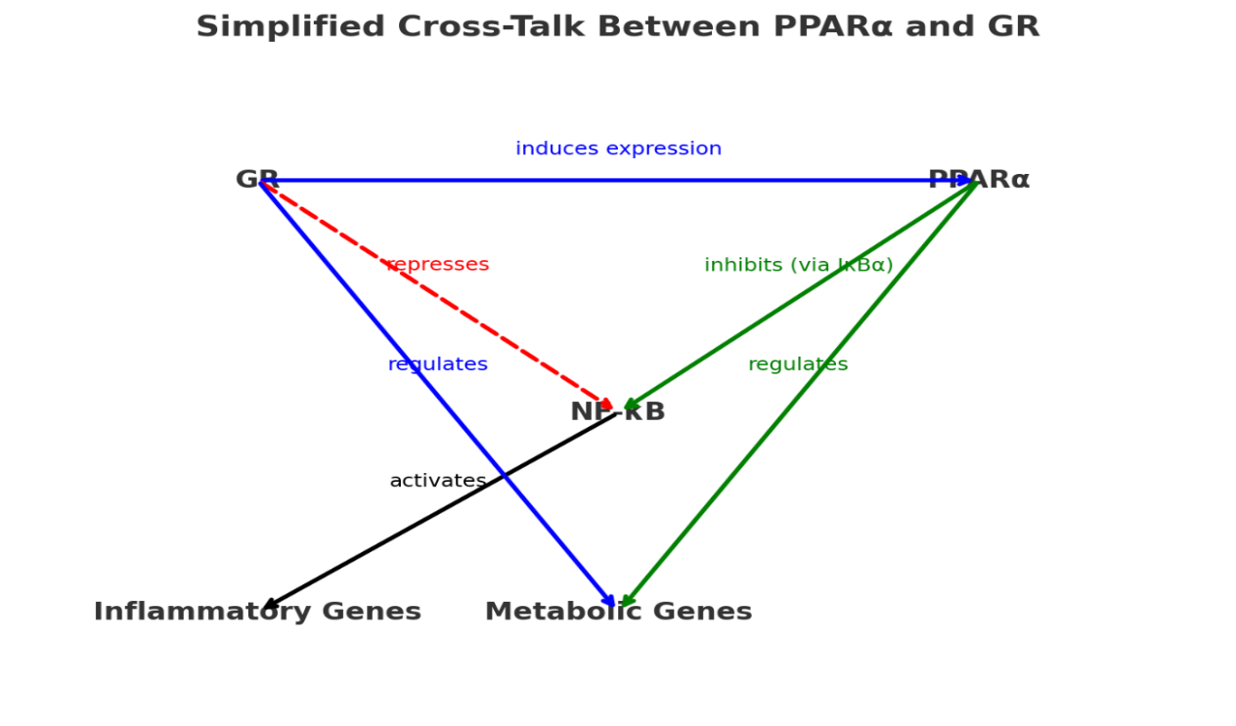
- Both GR and PPARα co-regulate metabolic genes

The Big Picture: A Powerful Partnership
Think of your body's response to stress and inflammation like managing a large company. Two key managers are:
- The Glucocorticoid Receptor (GR): The "Emergency Crisis Manager." Its job is to shut down inflammation immediately. It's powerful but can have significant side effects if overused (like a manager who burns out the team).
- PPARα: The "Metabolic & Long-Term Strategy Manager." Its main job is to manage your body's energy (burning fats, regulating sugar). But it also has a side role in calmly resolving inflammation and cleaning up after the crisis.
The key insight is that these two managers don't work in isolation. They are a team, and when they work together, they are far more effective and efficient than either one alone.

How They Work Together (The Mechanisms)
1. PPARα's Unique Trick to Calm Inflammation
- Normal Job: PPARα usually works by finding a specific DNA docking site (a PPRE) to turn genes on.
- Unique Trick: For the IκBα gene (which makes a protein that traps and inactivates the pro-inflammatory NF-κB), PPARα uses a different method.
- How it Works: Instead of docking itself, PPARα acts like a "booster." It goes to the IκBα gene's control room (promoter), which is already being activated a little bit by the NF-κB protein (p65). PPARα then helps recruit the right crew (a specific coactivator called DRIP205) to massively amplify the signal. The result is that the cell produces much more of the "stop-inflammatory" signal (IκBα).
2. The GR's Role: Direct Action and Hiring PPARα
- GR's Normal Job: The GR is a blunt instrument. It directly physically blocks NF-κB and other inflammatory proteins and slams on the brakes by recruiting proteins that shut down gene expression.
- GR's Strategic Move: The GR also increases the production of the PPARα protein itself. This is like the crisis manager hiring more strategic managers. This links the body's stress response (cortisol/GR) directly to its metabolic and resolution pathways (PPARα).
3. Synergy: The 1+1=3 Effect
When both PPARα and GR are active (i.e., when both managers are on the job at the same time), they don't just add their effects together—they multiply them.
- They attack the problem from multiple angles: GR is applying the direct brakes, while PPARα is boosting the cell's own anti-inflammatory machinery.
- They likely work as a pair: The text suggests they might physically stick to each other, forming a "super-complex" that is incredibly effective at shutting down inflammatory genes like those for IL-6 and MCP-1.
4. Coordinating Metabolism During Stress
During fasting or stress, the body needs to switch its energy source from sugar to fat. This process requires a coordinated change in hundreds of genes.
- PPARα and GR jointly control the genes needed for this metabolic shift.
- Another energy sensor, AMPK, is recruited to help them do this. This ensures that the body's inflammatory response and its metabolic response are perfectly in sync.
Why This Is a Big Deal (Therapeutic Implications)
Understanding this partnership opens up exciting new possibilities for medicine, especially for treating chronic inflammatory diseases like asthma, rheumatoid arthritis, or inflammatory bowel disease.
- The Problem with "Crisis Manager" (GR) Alone: Using steroid drugs (which activate GR) is very effective but has severe side effects like weight gain, diabetes, and bone thinning when used long-term.
- The Potential Solution: Combining a lower, safer dose of a steroid (GR activator) with a PPARα-activating drug (like a newer fibrate) could be much more effective than either drug alone.
- The Benefits:
  - Better Efficacy: The synergistic effect could control inflammation much better.
  - Lower Steroid Doses: Patients could potentially use a fraction of the steroid dose, drastically reducing harmful side effects.
  - Overcoming Resistance: This combo could work in patients who have become resistant to steroids alone.
In short, this isn't just about two proteins; it's about understanding a fundamental body-wide axis that integrates stress, metabolism, and inflammation. By leveraging this natural partnership, we can develop smarter, more effective, and safer anti-inflammatory therapies.

